Ideation Phase

Define the Problem Statements

|  |  |
| --- | --- |
| Date | 16 June 2025 |
| Team ID | LTVIP2025TMID55860 |
| Project Name | Shopsmart: Your Digital Grocery |
| Maximum Marks | 2 Marks |

**Customer Problem Statement Template:**

To define the core problems faced by customers and local grocery store owners in digital grocery shopping scenarios, and use those insights to guide the development of **ShopSmart**.

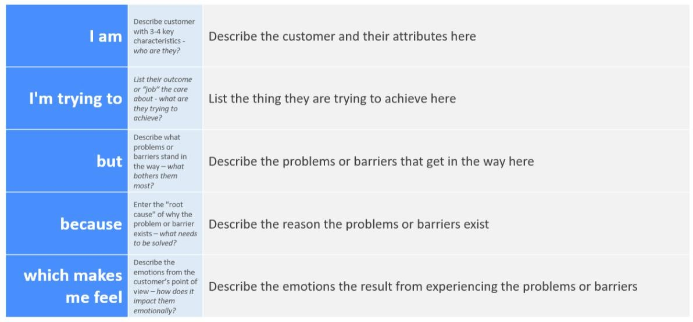

Reference: <https://miro.com/templates/customer-problem-statement/>

|  |  |  |  |  |  |
| --- | --- | --- | --- | --- | --- |
| **Problem Statement**  **(PS)** | **I am (Customer)** | **I’m trying to** | **But** | **Because** | **Which makes me feel** |
| **PS-1** | I am a busy working professional living in a  small town | order daily essentials and groceries  online | local stores aren’t listed on big grocery apps | they don’t serve low- density or remote areas | frustrated and underserved |
| **PS-2** | I am a local grocery store owner | sell my products online and expand my  reach | I lack a user- friendly digital platform | existing platforms are either expensive or  complex | excluded and left behind in the digital market |

|  |  |  |  |  |  |
| --- | --- | --- | --- | --- | --- |
| **PS-3** | I am a college student with limited time and budget | quickly find affordable groceries nearby | big apps don’t show price comparisons or local  offers | they focus on premium vendors only | limited in options and overpaying |
| **PS-4** | I am a homemaker managing household supplies | get groceries delivered on time from trusted  vendors | delivery schedules are unreliable and inconsistent | local coordination isn’t optimized by existing apps | anxious and inconvenienced |
| **PS-5** | I am a small- town resident new to online shopping | shop for groceries digitally | most platforms aren’t localized or available in  my language | they cater to metro cities primarily | confused and excluded |